PATIENT INFORMATION
EMP
FULL NAME____________________________ DATE OF BIRTH____/____/_____ AGE___ GENDER: MALE FEMALE
ADDRESS_________________________________________ APT #_______ SSN _______-_____-_________
CITY____________________________ STATE________ ZIP CODE______________ PHONE (____) ______-_______
CELL PHONE (______) ________-__________ EMAIL _____________________________@______________
EMERGENCY CONTACT___________________________ PHONE NUMBER (_____)________-__________ EXT _____
MARITAL STATUS: SINGLE MARRIED WIDOW PARTNERED
EMPLOYER’S NAME____________________________________ OCCUPATION_________________________________
WORK ADDRESS___________________________ CITY ___________________ STATE_________ ZIP CODE ________
WORK PHONE (____) ______-___________ EXT_______
PHYSICIAN INFORMATION
PRIMARY CARE PHYSICAN ________________________ PHONE NUMBER (____) _____-_______
OTHER DOCTOR________________________________ PHONE NUMBER (____) ______-______
CLAIM INFORMATION
IS THIS CONDITION DUE TO: AUTO ACCIDENT PERSONAL INJURY WORK INJURY OTHER
TYPE OF CLAIM: CASH GROUP HEATH INSURANCE PERSONAL INJURY WORKER’S COMP MEDICARE
TODAY I WILL BE PAYING BY: CASH CHECK MASTERCARD AMEX DISCOVER OTHER
INSURANCE INFORMATION
RELATIONSHIP TO INSURED: SELF CHILD SPOUSE SPOUSE’S NAME______________________
INSURED’S EMPLOYER: SAME AS ABOVE OTHER______________________________________________
INSURED’S SSN AND DOB: SAME AS ABOVE OTHER: SSN: ________-______-_______ DOB: _____-_____-_____
PRIMARY INSURANCE CO __________________________ ADDRESS_____________________________________
CITY___________________ STATE_____ ZIP CODE__________ PHONE NUMBER (______) _____-_______
POLICY NUMBER _______________________________________
SECONDARY INSURANCE CO_________________________ ADDRESS_____________________________________
CITY___________________ STATE_____ ZIP CODE__________ PHONE NUMBER (______) _____-_______
AUTHORIZATIONS
- I hereby authorize release of any medical information necessary to process this claim and request payment of insurance benefits either to myself or to the party who accepts assignment.
- I authorize payment of any medical benefit from third parties for benefits submitted from my claim to be paid directly to this office. I authorize the direct payment to this office of any sum I know or hereafter owe this office by my attorney, out of proceeds of any settlement of my case and by any insurance company contractually obligated to make payment to me or you based upon the charges submitted for products or services rendered.
- I understand and agree that health and accident policies are an arrangement between an insurance carrier and myself. Furthermore, I understand that this office will prepare any necessary reports to assist me in making collection from the insurance company and that any amount authorized to be paid directly to this office will be credited to my account upon receipt. However, I clearly understand and agree that all services rendered to me are charged directly to me and that I am personally responsible for payment. I understand that if I suspend or terminate my care and treatment, any fees for products or professional services rendered will be immediately due and payable.
Welcome to Physical Synergy
EMP
Your name: _________________________________________________
Who can we thank for referring you to our office?
Family: ____________________________________________________________
Friend: ____________________________________________________________
Website: ___________________________________________________________
Drive by: ___________________________________________________________
Do you take Yoga here? _______________________________________________
Other (please specify): ________________________________________________
Would you like to receive text messages confirming your appointments?
We will send you a text message the night before your appointment instead of calling you letting you know the date and time of your appointment. If you would like to sign up for this please provide the information below:
Cell phone number: _____________________________________________
Cell phone carrier: __________________________________________________
Signature: ______________________________________________date: _________________
Manual Therapy Appointment Cancellation Policy
If you need to cancel your manual therapy appointment please give us 24-hour notice. We do charge $50 for no shows or appointments that were not cancelled within the 24-hour time line.
Patient Signature: _____________________________________________date: __________

Full Name
EMP
1. Indicate on the drawings below where you have pain/symptoms
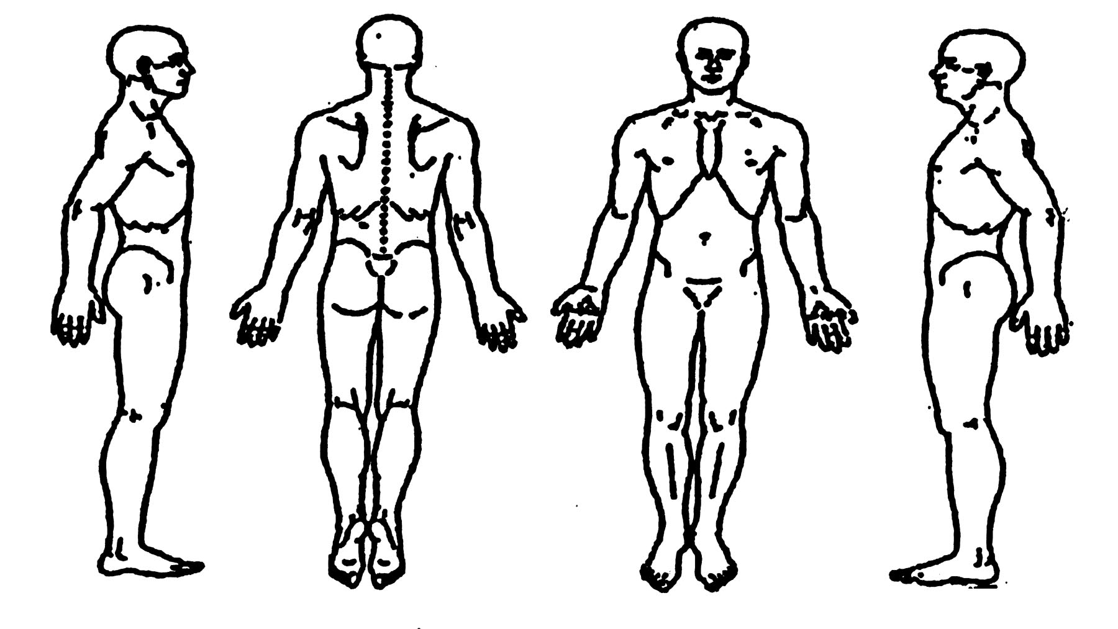
2. How often do you experience your symptoms?
□ Constantly (76-100% of the time) □ Intermittent (26-50% of the time)
□ Frequently (51-75% of the time) □ Occasional (1-25% of the time)

3. How would you describe the type of pain?
□ Sharp □ Numb
□ Dull □ Tingly
□ Diffuse □ Sharp with motion
□ Achy □ Shooting with motion
□ Burning □ Stabbing with motion
□ Shooting □ Electric like with motion
□ Stiff □ Other: ___________________

4. How are your symptoms changing with time?
□ Getting Worse □ Staying the Same □ Getting Better

5. Using a scale from 0-10 (10 being the worst), how would you rate your problem?
0 1 2 3 4 5 6 7 8 9 10 (Please circle)

6. How long have you had this problem? ___________

7. How do you think your problem began?
___________________________________________________________________________________________

8. Do you consider this problem to be severe?
□ Yes □ Yes, at times □ No

9. What aggravates your problem?
___________________________________________________________________________________________

10. What alleviates your problem?
___________________________________________________________________________________________

11. What concerns you the most about your problem?
___________________________________________________________________________________________

12. Anything else pertaining to your visit today? (prior history, health concerns or prior surgeries):
___________________________________________________________________________________________
___________________________________________________________________________________________
13. Help us understand how we can help you today:
How are you feeling?
- I want to be fixed ASAP! (firm pressure)
- can handle it for some time (medium pressure)
- I want to take my time (light pressure)
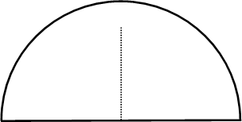
14. What is your pressure/touch tolerance for the treating area? (mark on dial)
(Example):

Light
Medium
Firm
For Med/Firm pressure mark as shown
Light
Medium
Firm

Full Name
EMP
15. What is your: Height___________ Weight _____________ Date of Birth ___________
Occupation _____________________________________________________

16. How would you rate your overall Health?
□ Excellent □ Very Good □ Good □ Fair □ Poor

17. What type of exercise do you do?
□ Strenuous □ Moderate □ Light □ None

18. Indicate if you have any immediate family members with any of the following:
□ Rheumatoid Arthritis □ Diabetes □ Lupus
□ Heart Problems □ Cancer □ ALS

19. For each of the conditions listed below, place a check in the "past" column if you have had the condition in the past. If you presently have a condition listed below, place a check in the "present" column.
Past Present  □ □ Headaches  □ □ Neck Pain  □ □ Upper Back Pain  □ □ Mid Back Pain  □ □ Low Back Pain  □ □ Shoulder Pain  □ □ Elbow/Upper Arm Pain  □ □ Wrist Pain  □ □ Hand Pain  □ □ Hip Pain  □ □ Upper Leg Pain  □ □ Knee Pain  □ □ Ankle/Foot Pain  □ □ Jaw Pain  □ □ Joint Pain/Stiffness  □ □ Arthritis  □ □ Rheumatoid Arthritis  □ □ Cancer  □ □ Tumor  □ □ Asthma  □ □ Chronic Sinusitis | Past Present  □ □ High Blood Pressure  □ □ Heart Attack  □ □ Chest Pains  □ □ Stroke  □ □ Angina  □ □ Kidney Stones  □ □ Kidney Disorders  □ □ Bladder Infection  □ □ Painful Urination  □ □ Loss of Bladder Control  □ □ Prostate Problems  □ □ Abnormal Weight Gain/Loss  □ □ Loss of Appetite  □ □ Abdominal Pain  □ □ Ulcer  □ □ Hepatitis  □ □ Liver/Gall Bladder Disorder  □ □ General Fatigue  □ □ Muscular Incoordination  □ □ Visual Disturbances  □ □ Dizziness | Past Present  □ □ Diabetes  □ □ Excessive Thirst  □ □ Frequent Urination  □ □ Smoking/Tobacco Use  □ □ Drug/Alcohol Dependence  □ □ Allergies  □ □ Depression  □ □ Systemic Lupus  □ □ Epilepsy  □ □ Dermatitis/Eczema/Rash  □ □ HIV/AIDS  For Females Only  □ □ Birth Control Pills  □ □ Hormonal Replacement  □ □ Pregnancy
□ □ Other: _________________________________________________________

20. List all prescription and over-the-counter medications you are currently taking:
_______________________________________________________________________________

21. List all of the supplements you are currently taking:
________________________________________________________________________________

22. List all surgical procedures you have had:
________________________________________________________________________________

22b. List all x-rays, MRI’s, CT Scans and/or other imaging you have had:
________________________________________________________________________________

23. What activities do you do at work?
□ Sit: □ Most of the day □ Half the day □ A little of the day
□ Stand: □ Most of the day □ Half the day □ A little of the day
□ Computer work: □ Most of the day □ Half the day □ A little of the day
□ On the phone: □ Most of the day □ Half of the day □ A little of the day

24. What activities do you do outside of work?
_________________________________________________________________________________

25. Have you ever been hospitalized? □ No □ Yes
If yes, why __________________________________________________________________________
26. Have you ever see a Chiropractor before? □ No □ Yes
If yes, when and for what_______________________________________________________________
27. Have you had significant past trauma? □ No □ Yes
28. Anything else pertinent to your visit today? ___________________________________________

Patient Signature___________________________________ Date: ____________________

Office Policy and Insurance
EMP

This agreement is between PHYSICAL SYNERGY and _____________________________________________. (patient name)
I ____________________________________________(patient name), do hereby authorize and agree to pay for services rendered to me by MICHAEL TROKNYA, D.C.,I.C.C.S.P., and/or CHARLES BENSON, D.C. during my course of treatment as agreed upon. I also hereby authorize and agree to pay in full any outstanding balance due on my account if requested at the time of my release from care.

I instruct an insurance carrier that may be liable to pay my physician directly for any outstanding medical bills.

I understand that if I have a personal injury protection policy (PIP) that it is the contractual obligation of my insurer to pay any and all medical bills, which are the result of an automobile accident, unless my benefits have been exhausted. I instruct any insurance company that may be liable to pay to pay my doctor within 30 days of the date of receipt of my claims, as required by the Connecticut Department of Insurance, by way of issuance of a separate draft make payable to PHYSICAL SYNERGY.

In the event I so choose to have any attorney represent me in this case, I do hereby instruct said attorney to pay in full any outstanding monies due my physician at the time of settlement with any liability claim that may result from this case. My attorney shall not withhold any portion of the amount due to my physician under this agreement to offset attorney’s fees. I also instruct my attorney to pay my doctor immediately upon settlement, by way of issuance of a separate draft made payable to PHYSICAL SYNERGY.

I understand and acknowledge that all charges incurred by me are my responsibility regardless of any settlement made by any insurance companies. I am instructing and agreeing to the above conditions as a safeguard to the physician’s right to collect payment.

I understand that PHYSICAL SYNERGY has the right to expect good faith payments on my account and that full payment is being deferred only until such time as any insurance company makes payment on my account. If a settlement does not occur within a reasonable amount of time, I agree to make other arrangements to pay my account in full.

I understand that PHYSICAL SYNERGY does not render any services on the assumption that their charges will be paid by any insurance company. Patients who carry health insurance should remember that professional services are rendered and charged to the patient if not paid in full by the insurance company. This excludes patients with an accepted workers’ compensation injury. Insured patients are expected to take care of their fees and/or patient portion as services are rendered. Even though an insurance claim is filed, you will receive a statement if your account has a balance due.

Methods of payment
(Accepted workers’ compensation patients are excluded)
- Payment at the time of service is expected unless prior arrangements are made in advance. Cash, checks and credit cards are accepted.
- If participating in the Well Care Program, which allows the patient to pay in advance for the recommended adjustments, and thereby receive subsequent savings, or other cash payment agreement, the patient’s insurance company will not be billed. However, if the patient suffers an injury or illness, which merits injury/illness care, the patient’s insurance may be utilized.

____________________________________________________________ ____________________________________
Patients Signature Date

_____________________________________________________________ ____________________________________
Patient’s Parent or Guardian Signature Date

Acknowledgement and Agreement of Receipt
As the insurance adjuster or attorney on this claim, I acknowledge that I have received notice of the patient’s agreement above and will abide as agreed upon and instructed from _____________________________________________ (patient’s name).

____________________________________________________________ ____________________________________
Adjuster or Attorney Signature Date

Consent for Purposes of Treatment, Payment & Healthcare Operations
EMP

In this document, “I” and “my” refer to the patient and “Chiropractor” refers to Physical Synergy

I consent to the use or disclosure of my protected health information by Chiropractor for the purpose of analyzing, diagnosing or providing treatment to me, obtaining payment for my health care bills or to conduct health care operations of Chiropractor. I understand that analysis diagnosis or treatment of me by Chiropractor may be conditioned upon my consent as evidenced by my signature below.

I understand I have the right to request a restriction as to how my protected health information is used or disclosed to carry out treatment, payment or healthcare operations of the practice. Chiropractor is not required to agree to the restrictions that I may request. However, if I have the right to revoke this consent, in writing, at any time, except to the extent that Chiropractor has taken action in reliance on this Consent.

My “protected health information” means health information, including my demographic information, collected from me and created or received by my physician, another health care provider, a health plan, my employer or health care clearinghouse. This protected health information relates to my past, present or future physical or mental health or condition and identifies me, or there is a reasonable basis to believe the information may identify me.

I have been provided with a copy of the Notice of Privacy Practices of Chiropractor and understand that I have a right that Notice’s Notice of Privacy Practices prior to signing this document. The Notice of Privacy Practices describes the types of uses and disclosures of my protected health information what will occur in my treatment, payment of my bills or in the performance of health care operations of Chiropractor. The Notice of Privacy Practices for Chiropractor is also posted in the waiting room at Physical Synergy. This Notice of Privacy Practices also describes my rights and duties of the Chiropractor with respect to my protected health information.
Chiropractor reserves the right to change the privacy practices that are described in The Notice of Privacy Practices. I may obtain a revised notice of privacy practices by calling the office of the Chiropractor and requesting a revised copy be sent in the mail or asking for one at the time of my next appointment.

___________________________________________ ______________________________________
Signature of Patient/Personal Representative Printed Patient Name

___________________ _____________________________________________________________
Date of Signing Description of Personal Representative’s Authority
EMP

PATIENT ACKNOWLEDGEMENT OF
RECEIPT OF NOTICE

I hereby acknowledge receipt of the Notice of Privacy Practices for Physical Synergy regarding my health information. I have been informed and understand the manner in which my health information shall be maintained, utilized and disclosed by clinic and my respective rights contained therein. I also understand that the Notice furnished to me is subject to change at any time. I am aware that I may obtain a current copy of this Notice at any time by contacting Jeanine Puma, Clinic Privacy Officer, 203-259-3210, 340 Post Road, Fairfield, CT 06824
My signature herein below constitutes full acknowledgement that I have been furnished a copy of the Notice of Privacy Practices for Physical Synergy.

____________________________________________ _____________________________________
Patient Signature/parent or guardian Date
____________________________________________ ______________________________________
Patient’s legal representative Date
(If required)

I signed by a patient’s legal representative, please state representative’s relationship to patient
__________________________________________________

